## Install jenkins and run jenkins on port number 8081.

Java prerequisites

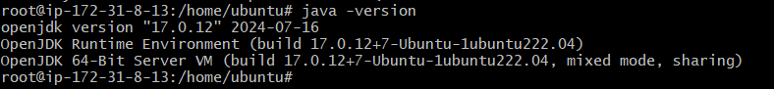

Installed jenkins

Running on port number 81

## Secure Jenkins server

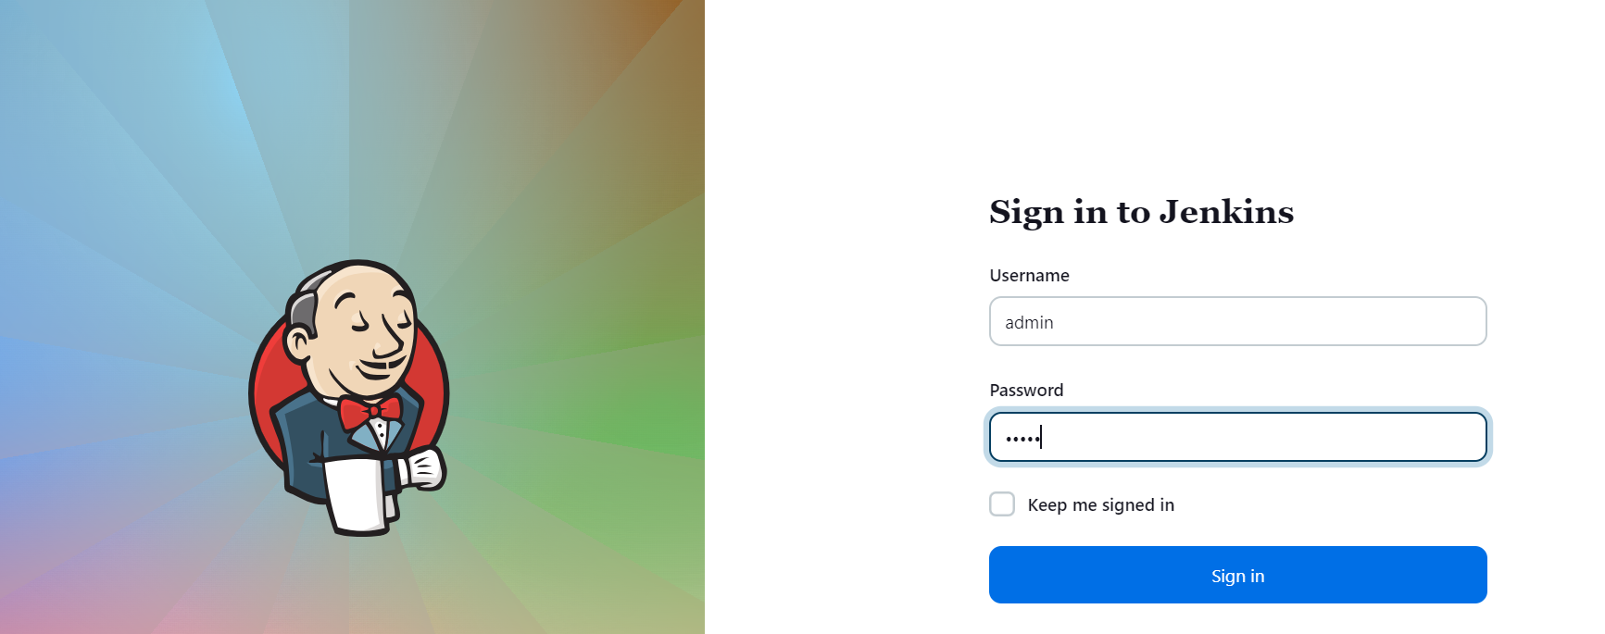

## Create users called Devops, Testing in Jenkins with Limited access.

## Configure labels and restrict the jobs to execute based on label only.

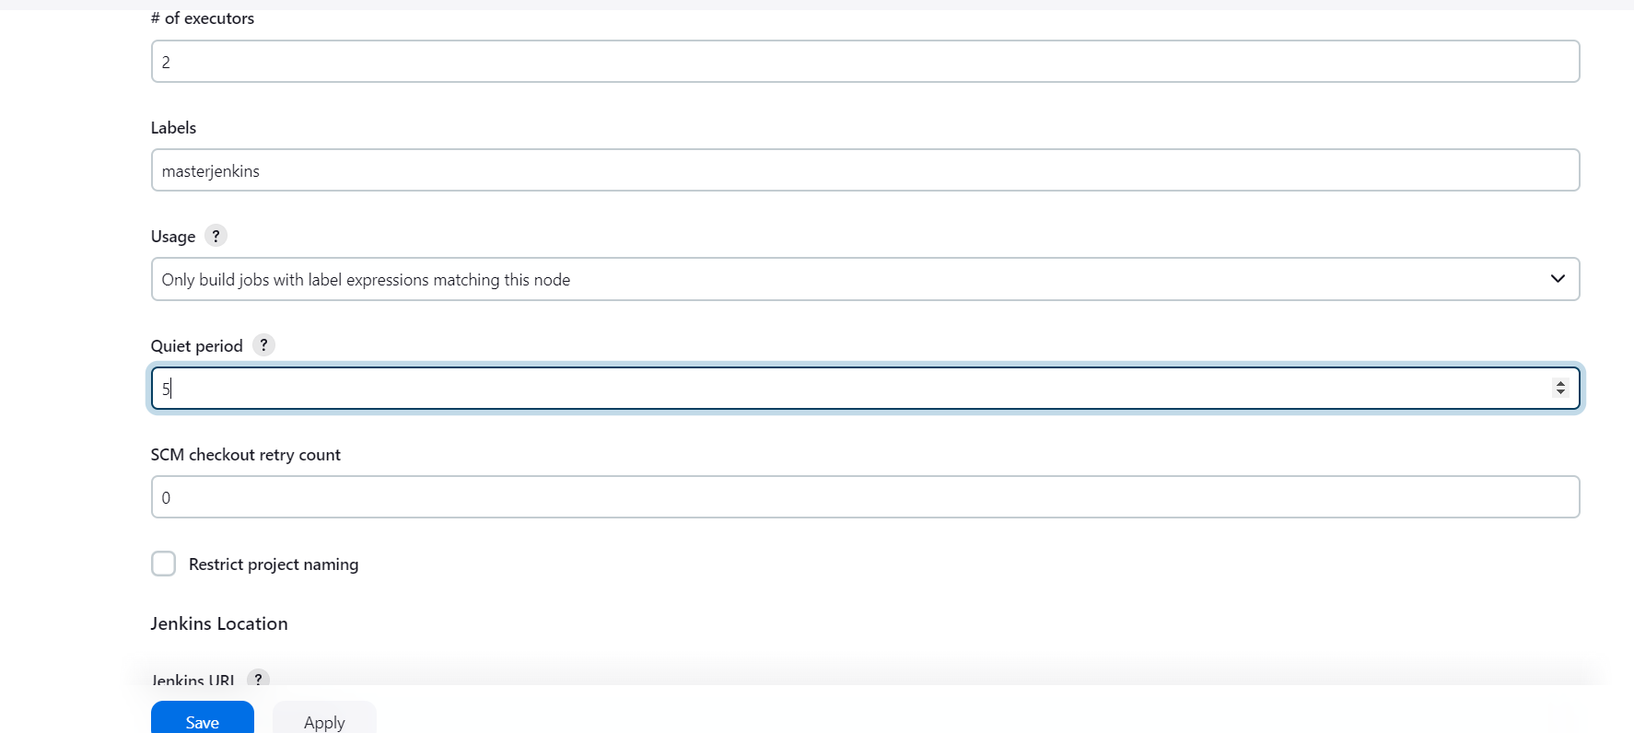

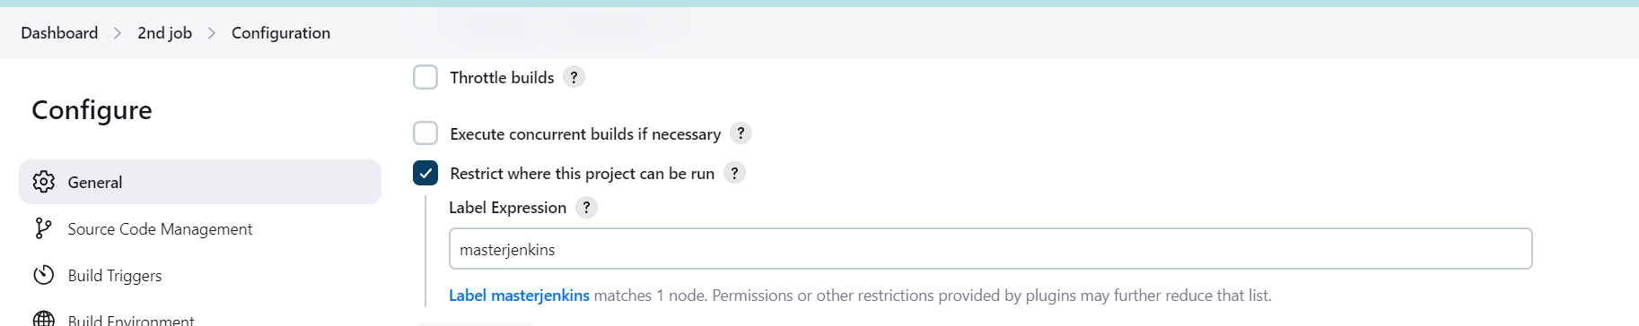

## 5) Create Three sample jobs using the below url

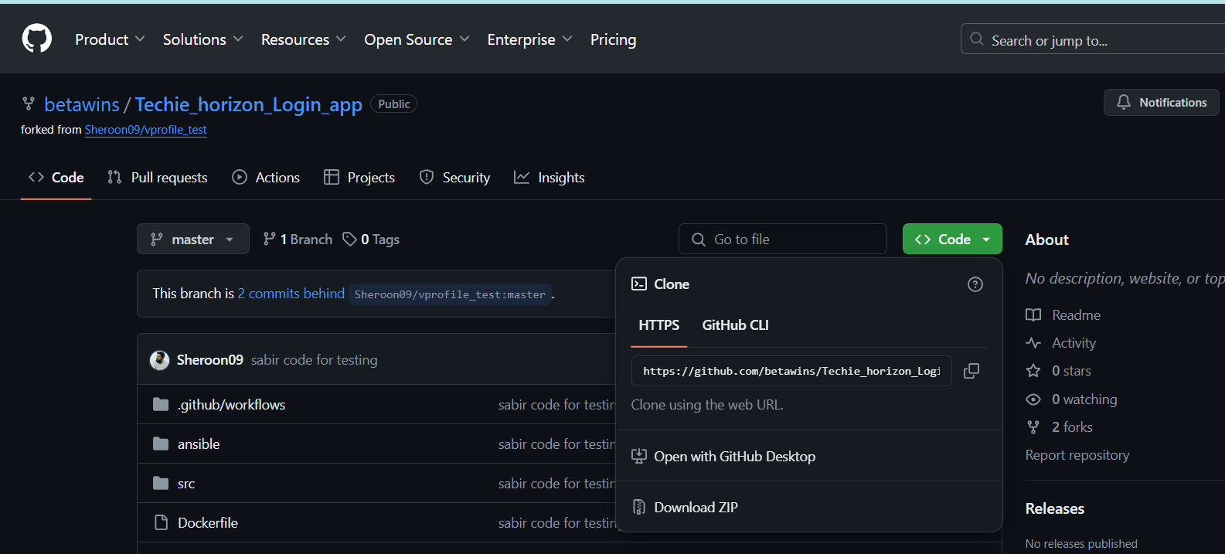

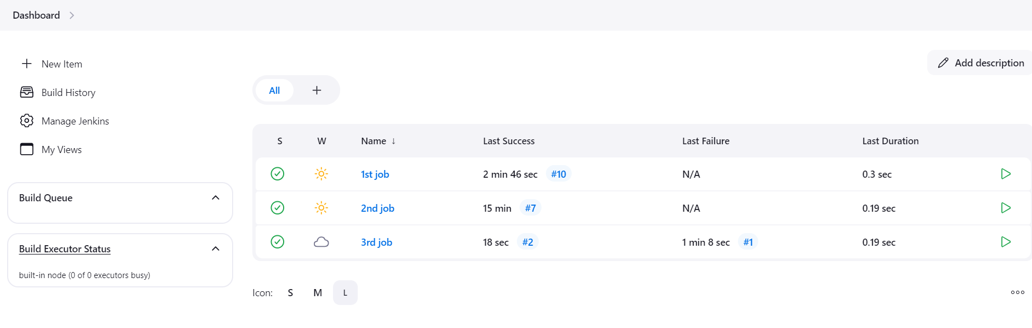

## 6)Create one jenkins job using git hub Private repository.

